USER INTERFACE DESIGN
EXPERIMENT-4

NAME: ZARAA JUHI SAAI K
ROLL NO:240701044

SCREEN-1: SPLASH SCREEN
Familiar Elements:
- App Logo – Centre of Screen:
o A common element displayed when the application starts.
o It represents the brand identity of the app.
- App Name Text – Below Logo:
o Most applications display their name during launch.
o Helps users identify the application immediately.
Unfamiliar Elements:
- Gradient Background Animation:
o Instead of a plain background, a gradient animation is used.
o It creates a modern and visually attractive first impression.

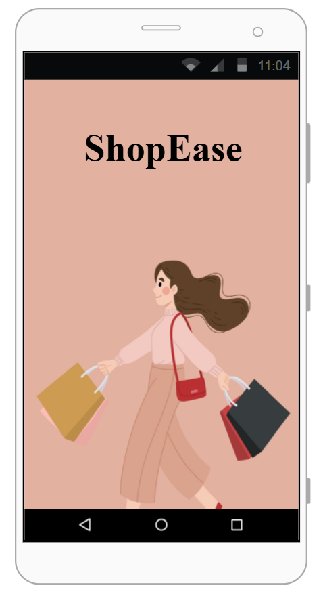
SCREEN 2:LOGIN PAGE
Familiar Elements:
- Email Input Field:
o A standard text field used to enter user email.
o Commonly found in almost all applications.
- Password Input Field:
o Used to securely enter password.
o Characters are hidden for privacy.
- Login Button:
o Clicking it allows the user to proceed to the home screen.
Unfamiliar Elements:
- Rounded Input Field Design:
o Instead of normal rectangular fields, rounded corners are used.
o Gives a modern and soft UI appearance.
- Animated Button Effect:
o Button slightly changes when tapped.
o Enhances user interaction experience.
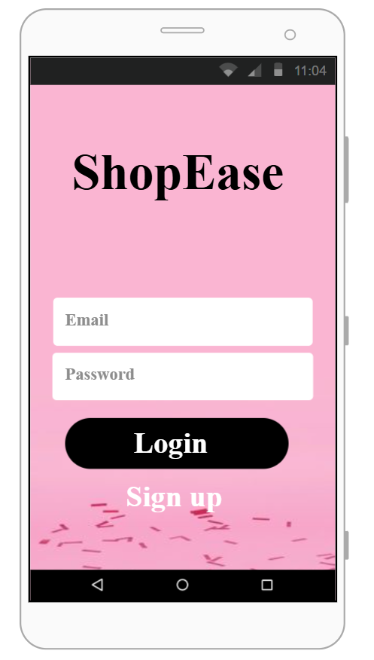

SCREEN 3: HOME PAGE
Familiar Elements:
- Search Icon (🔍):
o A widely recognized symbol for search functionality.
o Helps users quickly find products.
- Product Cards (Image + Price):
o Standard layout used in shopping applications.
o Displays product details clearly.
- Bottom Navigation Bar:
o Contains icons like Home, Cart, and Profile.
o Common navigation pattern in mobile apps.
Unfamiliar Elements:
- Horizontal Product Scrolling:
o Products scroll sideways instead of vertically.
o Slightly different from traditional layouts.
- Floating Category Icons:
o Circular floating icons used for category selection.
o Adds uniqueness to the design.
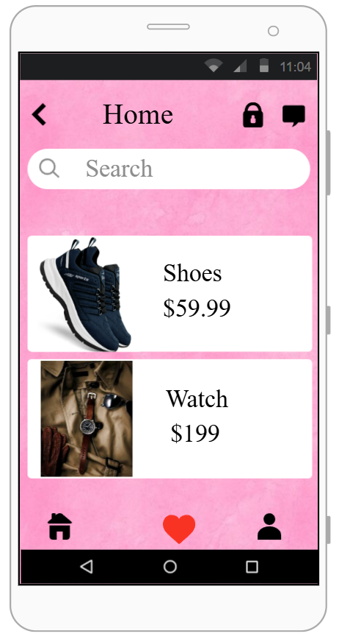
SCREEN 4: PRODUCT DETAILS PAGE
Familiar Elements:
- Back Arrow (←):
o Used to return to the previous screen.
o Common navigation element.
- Add to Cart Button:
o Used to add selected product to cart.
o Standard feature in e-commerce apps.
Unfamiliar Elements:
- Swipe Gesture for Additional Details:
o Users swipe to view extra product information.
o Different from normal scrolling method.
- Image Transition Animation:
o Product image changes with animation.
o Makes interface more interactive.
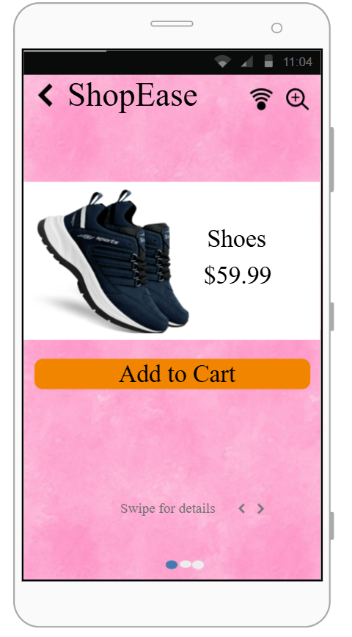
SCREEN 5: CART PAGE
Familiar Elements:
- Quantity Increase/Decrease (+ / -):
o Allows users to modify product quantity.
o Common shopping cart feature.
- Checkout Button:
o Used to proceed to payment.
o Standard action button in e-commerce apps.
Unfamiliar Elements:
- Swipe to Remove Option:
o Product can be removed by swiping.
o Alternative to delete button.
- Slide Animation on Removal:
o Product smoothly slides out when removed.
o Improves user experience.
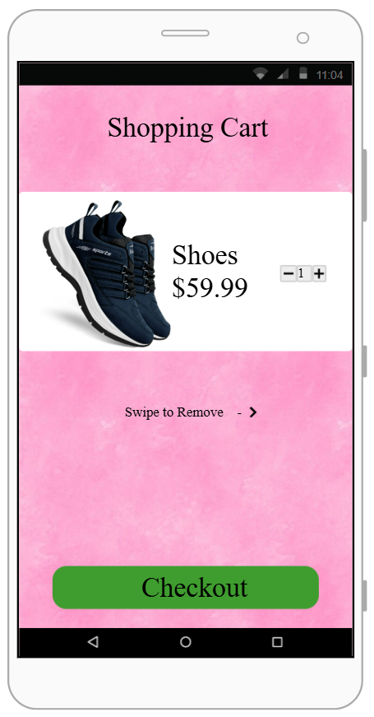
SCREEN 6: ORDER CONFIRMATION PAGE
Familiar Elements:
- Green Tick Mark (✔):
o Universal symbol indicating success.
o Used in most applications after successful action.
- Confirmation Message:
o Displays “Order Successful” text.
o Informs user that transaction is completed.
Unfamiliar Elements:
- Confetti Animation Effect:
o Celebration animation after order completion.
o Creates emotional satisfaction.
- Full-Screen Success Display:
o Entire screen focuses on confirmation message.
o Enhances visual impact.
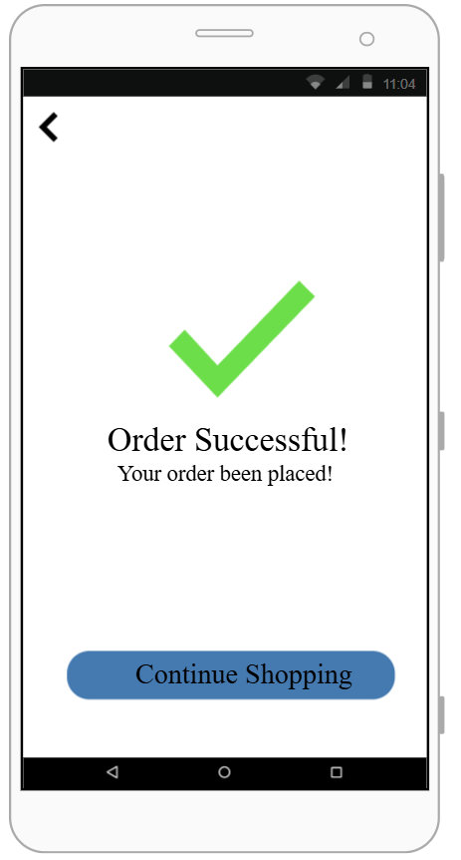

PROTOTYPE LINK:
https://pr.to/LX4L8Y/

